

Project - Low Level Design

on
Multimodal Education Creator

Course Name: Gen AI

Institution Name: Medicaps University – Datagami Skill Based Course

Student Name(s) & Enrolment Number(s):

Sr no | Student Name | Enrolment Number
1. | Leeni Patidar | EN22CS301554
2. | Mahak Agrawal | EN22CS301563
3. | Kunal Singh Chouhan | EN22CS301540
4. | Krishna Patidar | EN22CS301523

Group Name: 04D5
Project Number: GAI-04
Industry Mentor Name:
University Mentor Name:
Academic Year:2026




1.Introduction
Multimodal GenAI Education Concept Visualization System
The Multimodal GenAI Education Concept Visualization System is an advanced AI-powered educational platform designed to transform traditional learning into an interactive, engaging, and highly effective experience. Conventional learning systems primarily rely on textual content, which can often limit understanding, especially for complex or abstract concepts. This system addresses that gap by leveraging state-of-the-art Generative Artificial Intelligence technologies to provide both textual explanations and visual representations simultaneously.
The platform integrates powerful Large Language Models (LLMs) such as OpenAI GPT API and Google Gemini API for generating high-quality, context-aware textual content. In parallel, it utilizes advanced image generation models like DALL·E and Stable Diffusion to create relevant diagrams, illustrations, and visual aids from the same user input. By processing a single prompt, the system produces a combination of detailed explanations, structured summaries, visual diagrams, and flashcards, thereby enabling a truly multimodal learning environment.
This approach significantly enhances comprehension by allowing learners to both read and visualize concepts, improves retention through visual memory reinforcement, and increases engagement by making the learning process more interactive. The system is designed to be beneficial for a wide range of users, including students, educators, and professionals, and can be applied across multiple domains such as science, mathematics, programming, and technical education. Overall, the project demonstrates the effective synergy between text-to-text and text-to-image AI models in delivering comprehensive and intelligent educational content.
1.1 Scope of the Document
This document provides a comprehensive and in-depth description of the Multimodal GenAI Education Concept Visualization System, covering all major aspects related to its design, architecture, implementation, and functionality. It serves as a complete technical reference for understanding how the system is structured and how different components interact with each other.
- Describes the overall system architecture, including frontend, backend, and AI service integrations
- Explains module-level design such as content generation, image generation, and flashcard creation
- Details data processing workflows, including input handling, prompt engineering, and response generation
- Covers API integrations with external AI services for both text and image generation
- Highlights key design decisions, including model selection, scalability considerations, and performance optimization
- Defines system constraints such as latency, API limitations, and resource usage
- Provides insights into error handling, validation mechanisms, and system reliability
- Serves as a development guide for implementing and extending system features
- Acts as a validation reference for testers to ensure correct system behavior
- Helps stakeholders and evaluators assess the technical feasibility, innovation, and completeness of the project
- Ensures consistency in development by clearly defining system boundaries, expected inputs/outputs, and functional behavior
1.2 Intended Audience
This document is intended for a diverse group of stakeholders involved in the design, development, evaluation, and use of the system. It is written in a structured and formal manner to ensure clarity, readability, and ease of understanding across different technical backgrounds.
- Software Developers
  - Understand system flow, architecture, and implementation details
  - Use it as a guide for building, maintaining, and extending system modules
- AI and Machine Learning Engineers
  - Analyze integration of language and image models
  - Optimize model performance, prompt design, and output quality
- System Architects
  - Evaluate design decisions, scalability, and modularity
  - Assess system robustness and future extensibility
- Test Engineers / QA Teams
  - Validate system functionality against defined workflows
  - Ensure correctness, performance, and reliability
- Project Evaluators and Academic Faculty
  - Assess innovation, technical depth, and implementation quality
  - Review alignment with modern AI trends and educational impact
- Students and Researchers (Optional Audience)
  - Understand practical applications of Generative AI in education
  - Use the system as a reference for similar academic or research projects
The document ensures that all stakeholders can clearly understand the system’s objectives, structure, and functionality, thereby enabling efficient collaboration, evaluation, and future enhancements.
1.3 System overview:
The Multimodal GenAI system is designed to accept a user-defined topic or concept as input and generate multiple forms of educational content as output. When a user enters a prompt such as a scientific concept or technical topic, the system processes the input and produces a detailed explanation using a large language model. Simultaneously, it generates a relevant visual representation using an image generation model, which helps in illustrating the concept more effectively. In addition to textual and visual outputs, the system also creates flashcards by extracting key points from the generated content, enabling users to quickly revise and reinforce their understanding. The overall objective of the system is to transform complex and abstract concepts into structured, easy-to-understand, and visually enriched content, thereby enhancing the overall learning experience. The system also incorporates a vector database such as Pinecone or FAISS to store embeddings and enable semantic search capabilities.

2.System Design

The system follows a modular client-server architecture designed to efficiently generate and deliver multimodal educational content by integrating Large Language Models (LLMs) and Image Generation APIs. The architecture ensures separation of concerns, scalability, and maintainability by dividing responsibilities across distinct layers. It enables seamless transformation of a single user prompt into structured textual explanations, visual representations, and flashcards while maintaining performance and reliability.

2.1Application Design

The application is structured into multiple interconnected layers, each responsible for a specific function in the system. The frontend layer is developed using React and serves as the user interface, allowing users to input prompts and view generated outputs including text, images, and flashcards in an interactive format. It communicates with the backend through RESTful API calls. The backend layer is implemented using Python frameworks such as FastAPI or Flask and acts as the core processing unit of the system. It handles incoming requests, performs input validation, manages prompt engineering, coordinates with AI services, and aggregates responses before sending them back to the frontend.

The AI services layer consists of two major components: Large Language Models and Image Generation Models. The LLM component utilizes APIs such as OpenAI GPT or Google Gemini to generate detailed, context-aware textual explanations. The image generation component uses models like DALL·E or Stable Diffusion to produce relevant diagrams and visual representations based on the same prompt.

The system also includes a database and vector database layer. The traditional database is used to store user inputs, generated outputs, and system logs, while the vector database (such as FAISS) enables semantic search and retrieval by storing embeddings of prompts and generated content. This allows the system to reuse or retrieve similar content efficiently, improving performance and user experience.

2.1 Process Flow

The system follows a well-defined sequence of operations to convert user input into multimodal output. The process begins when the user enters a prompt through the frontend interface. This prompt is sent to the backend server via an API request. Upon receiving the request, the backend validates the input and performs preprocessing, including prompt refinement and formatting to ensure better results from AI models.

The refined prompt is then sent to the Large Language Model, which generates a detailed textual explanation of the concept. Simultaneously or sequentially, the same prompt is sent to the image generation model to create a relevant visual representation such as a diagram or illustration. After generating text and image outputs, the backend processes the textual content further to create structured flashcards that summarize key points for quick learning and revision.
All generated data, including the prompt, text output, image references, and flashcards, are stored in the database for future access and analysis. If a vector database is used, embeddings of the content are also stored to support semantic retrieval. Finally, the backend compiles all outputs and sends them back to the frontend, where they are displayed in an organized and user-friendly format.

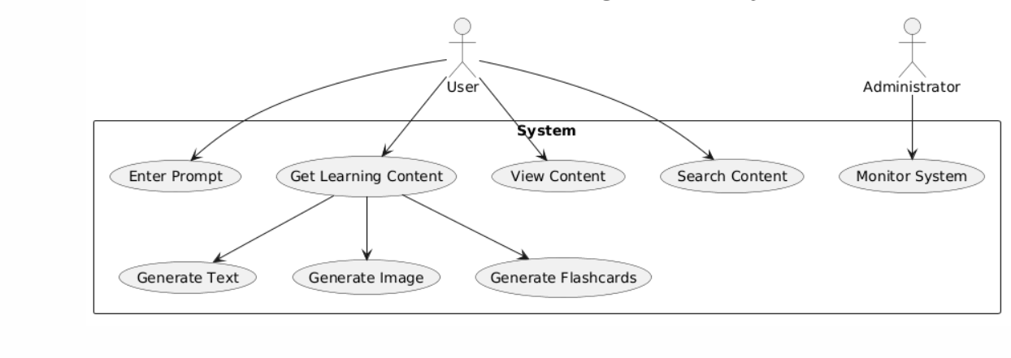

2.2 Information Flow

The information flow within the system ensures smooth communication between all components and efficient data transformation. The flow starts from the user interface, where the input prompt is captured and transmitted to the backend through HTTP requests. The backend acts as the central controller, routing the processed prompt to different AI services.

The prompt first undergoes preprocessing and is then forwarded to the LLM API, which returns structured textual data. The same or slightly modified prompt is sent to the image generation API, which returns image URLs or encoded image data. The backend then integrates these outputs and performs additional processing such as flashcard generation and formatting.
Simultaneously, the processed data is stored in the database, and embeddings are generated and stored in the vector database for semantic search capabilities. The final combined response, including text, images, and flashcards, is sent back to the frontend. The frontend renders this information visually, ensuring that users receive a cohesive and interactive learning experience. 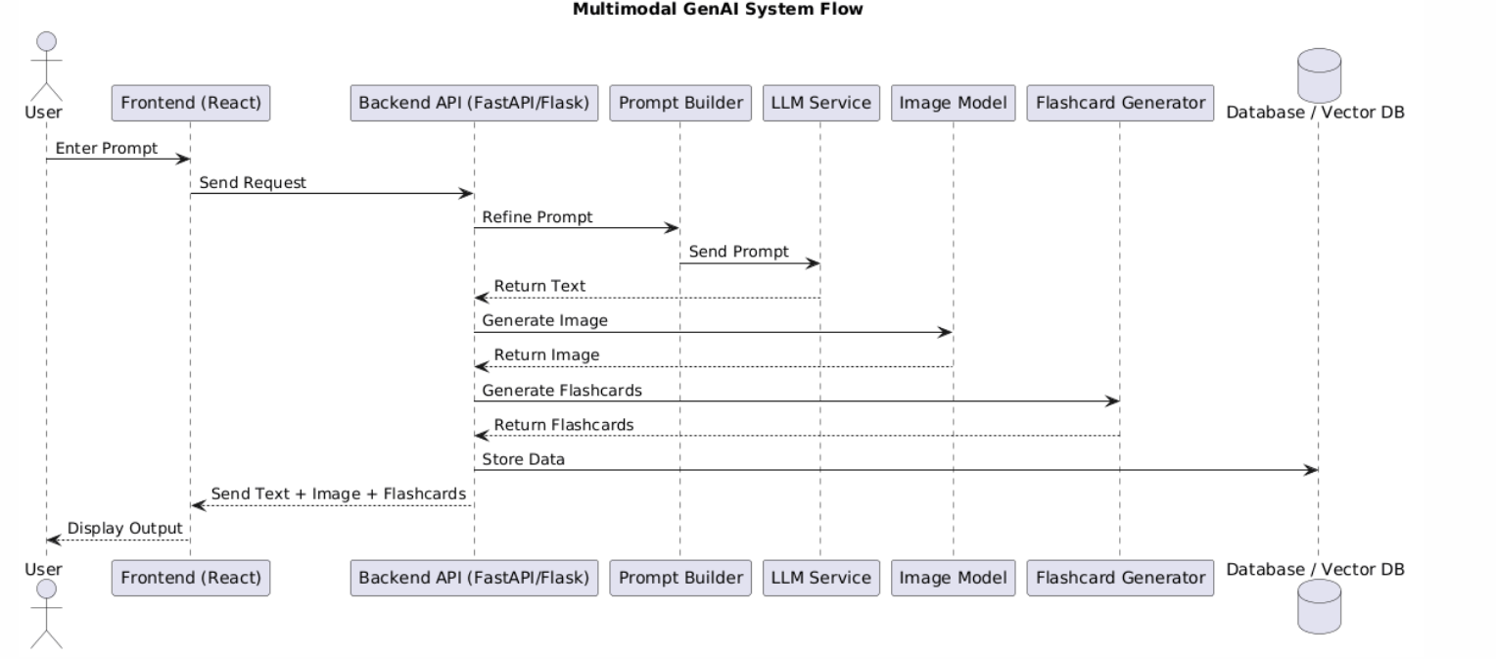

3.Components Design
The system is composed of multiple well-defined components that work together to deliver multimodal educational content in a seamless and efficient manner. The frontend component is developed using React and is responsible for capturing user input, managing UI state, and presenting generated outputs such as explanations, images, and flashcards in an intuitive format. It communicates with the backend using RESTful APIs and ensures a responsive user experience.
The backend component, built using Python frameworks like FastAPI or Flask, acts as the central orchestration layer. It handles request validation, authentication, routing, prompt preprocessing, and coordination between different AI services. It also manages response aggregation and formatting before sending results back to the frontend.
The LLM service component integrates APIs such as OpenAI GPT or Google Gemini and is responsible for generating high-quality textual explanations, summaries, and structured content based on user input. It includes prompt engineering logic to improve output accuracy and relevance.
The image generation component integrates models like DALL·E or Stable Diffusion to generate diagrams, illustrations, or concept visuals that complement the textual output. It ensures that the generated images are contextually aligned with the user’s query.
The flashcard generation component processes the LLM output to extract key concepts and converts them into concise question-answer pairs for quick revision and learning reinforcement.
The database component stores user prompts, generated outputs, metadata, and logs for persistence and future retrieval. It ensures data consistency and supports content history features.
The vector database component, such as FAISS, stores embeddings of text data to enable semantic search and similarity-based retrieval, improving efficiency and reducing redundant API calls.
The API layer exposes endpoints for all system functionalities, acting as the interface between frontend and backend services. It ensures standardized communication and supports scalability.

3.2 Key Design Considerations
The system is designed with a focus on performance, scalability, security, and maintainability. Fast response time is achieved through asynchronous processing, allowing multiple API calls to LLM and image services to run concurrently, thereby reducing latency. Scalability is ensured through a modular architecture that allows independent scaling of components such as backend services, AI integrations, and databases.
Security is maintained through proper API key management, authentication mechanisms, and validation of incoming requests to prevent misuse or unauthorized access. The system emphasizes accurate AI output by incorporating prompt engineering techniques, response validation, and fallback mechanisms to handle uncertain or low-quality responses.
The modular design approach ensures that each component can be updated or replaced independently without affecting the overall system, making it future-proof and easy to maintain. Cost optimization is considered by minimizing redundant API calls, using caching strategies, leveraging vector search for reuse of similar results, and selecting appropriate model configurations based on task requirements.

3.3 API Catalogue
The system provides a set of well-defined RESTful APIs to handle all core functionalities. The Generate Content API (POST /api/v1/generate) is the primary endpoint that accepts a user prompt and triggers the complete pipeline, including text generation, image creation, and flashcard generation, returning a combined multimodal response.
The Save Content API (POST /api/v1/content/save) is used to store generated content in the database, including text, image references, and flashcards, along with associated metadata for future retrieval.
The Fetch Content API (GET /api/v1/content/{id}) allows retrieval of previously saved content using a unique identifier, enabling users to revisit or reuse generated educational material.
The Search Content API (GET /api/v1/search?q=topic) provides semantic search functionality by querying the vector database to find relevant content based on meaning rather than exact keyword matching, improving search accuracy and user experience.
The Health Check API (GET /api/v1/health) is used to monitor the status of the backend service and ensure that all components are functioning correctly, which is essential for system reliability and maintenance.

4.References:

The system leverages a combination of advanced AI models, modern web frameworks, and efficient data processing tools to build a robust multimodal educational platform. Each technology plays a critical role in enabling text generation, image synthesis, backend processing, semantic search, and workflow orchestration.
- OpenAI GPT API and Google Gemini API are used as the primary Large Language Models for generating high-quality textual content, including detailed explanations, summaries, and structured educational material. These models provide context-aware and coherent outputs, making them suitable for transforming user prompts into meaningful learning content.

- DALL·E and Stable Diffusion are utilized for image generation, enabling the system to create diagrams, illustrations, and visual representations directly from textual input. These models enhance understanding by providing visual context alongside textual explanations.

- FastAPI and Flask are used for backend development, handling API routing, request processing, and integration with AI services. FastAPI is particularly beneficial for high-performance asynchronous operations, while Flask offers simplicity and flexibility for lightweight implementations.

- Pinecone and FAISS are employed as vector databases to store embeddings of textual data, enabling semantic search and similarity-based retrieval. This allows the system to efficiently find relevant content based on meaning rather than exact keyword matches, improving performance and reducing redundant computations.

- React and LangChain are used for frontend development and AI workflow orchestration respectively. React provides a dynamic and responsive user interface for interacting with the system, while LangChain helps in managing prompt flows, chaining multiple AI calls, and structuring complex interactions between language and image models

